SYSTEM DENRDOGRAM
ASSIGNMENT-1
M. CHARAN RAJ
1602-20-737-009
ABSTRACT:
The Dendrogram is a visual representation of the compound correlation data. It is a type of tree diagram showing hierarchical clustering relationships between similar sets of data. This project aims about drawing dendrogram for system. Here we draw dendrogram for different systems.

Requirement Analysis
List of Tables:
1.Chassis
2. Memory
3. ALU (Arithmetic Logic Unit)
4.CU (Control Unit)

List of Attributes with their Domain Type:
Chassis:
Manufacturer varchar2(30)
Length number
Width number
Weight number

Memory:
Manufacturer varchar2(30)
cap_of_RAM number
Mid number
cap_of_HardD number

DESIGN
Entity Relationship Diagram

Input
Output
Memory
Weight
Length
Input
Manufacturer
Manufacturer
Mid
Cap of Hard Drive
Control Unit
Width
Manufacturer
Cap of Ram
Memory
Output
Manufacturer
Memory
ALU
Chassis
CPU

DDL OPERATIONS:
1)
create table chasis(
manufacturer varchar2(30) not null,
length number,
width number,
weigth number);

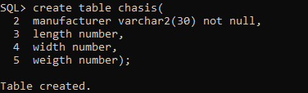

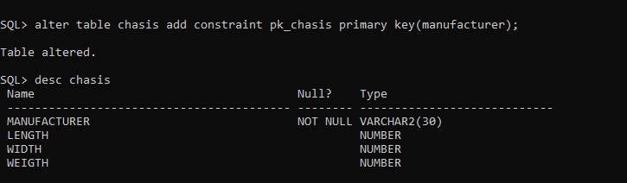

2)
create table memory(
manufacturer varchar2(30) not null,
cap_of_RAM number,
Mid number,
cap_of_HardD number);

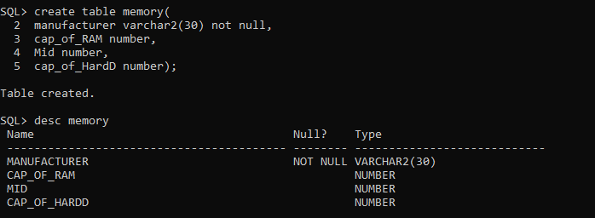

DML OPERATIONS:
Inserting values into tables

